Ideation Phase

Define the Problem Statements

|  |  |
| --- | --- |
| Date | 19 September 2022 |
| Team ID | PNT2022TMID50005 |
| Project Name | News Tracker Application |
| Maximum Marks | 2 Marks |

# Customer Problem Statement Template:

Create a problem statement to understand your customer's point of view. The Customer Problem Statement template helps you focus on what matters to create experiences people will love.

A well-articulated customer problem statement allows you and your team to find the ideal solution for the challenges your customers face. Throughout the process, you’ll also be able to empathize with your customers, which helps you better understand how they perceive your product or service.

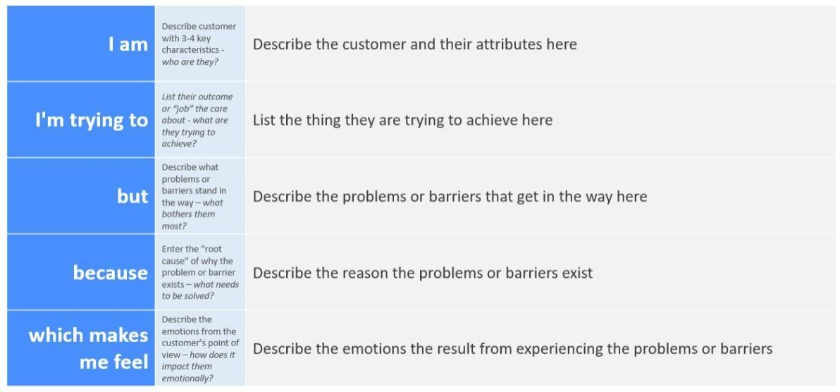

# USER PERSPECTIVE:

|  |  |  |  |  |  |
| --- | --- | --- | --- | --- | --- |
| **Problem Statement (PS)** | **I am (USER)** | **I’m trying to** | **But** | **Because** | **Which makes me feel** |
| PS-1 | Is it belonging all the age groups | I try to do track relevent news based on their  ages. | Is it any compulsion to do that | It make me embarassed | We will tried level best to track all type age datas If it happens it makes me happy. |
| PS-2 | If an mobile app user whether we give all personal details what the app  expecting from us. | The Given details are should be verified by an admin side . | There are many apps can't secured the data in a proper manner | The updation of an app can't be prolonged. | Unsecured to give my personal datas. |
| Ps -3 | There is any feature to search the option if user want to track particular  news | When there is an helpless situation appeared. | The connections to helpline response as much earlier | Because it is easy to track the data. | It make teams happy, if caught their searching data. |